Documentation:

Screen Sharing:

OntopReplica

&

Spacedesk

By: Ruben Thomas Y. Reyes III

Date: 10/21/2023

Software needed for all computers:

1. Spacedesk ( <https://www.spacedesk.net/> )
2. Ontopreplika ( <https://github.com/LorenzCK/OnTopReplica/releases>)

To start off, every computer in the lab should be connected to the same network. Make sure that every computer can be pinged and communicate with each other. This can be done by using the “ping” command. After that if all computers can communicate with each other and they are in the same network then have all of them install **Spacedesk** and **Ontopreplika**.

Spacedesk enables computers to duplicate or extend their screens using either an ethernet or Wi-Fi connection. The quality of the screen sharing experience depends on the speed and stability of the chosen network connection. Spacedesk provides two distinct files for download. The first is the 'Spacedesk driver,' which acts as the source for the computer you intend to share your screen from. The second file, 'Spacedesk viewer,' serves as the secondary display for the source. It is recommended for all computers to have both applications installed, allowing students and professors to seamlessly share their screens with one another.

**Step by Step Guide in how to use Spacedesk:**

**1.) Open the Spacedesk driver console and ensure that the driver is turned on.**  **Turning the driver on allows it to be recognized on the network by other computers**  **with the Spacedesk viewer application.**

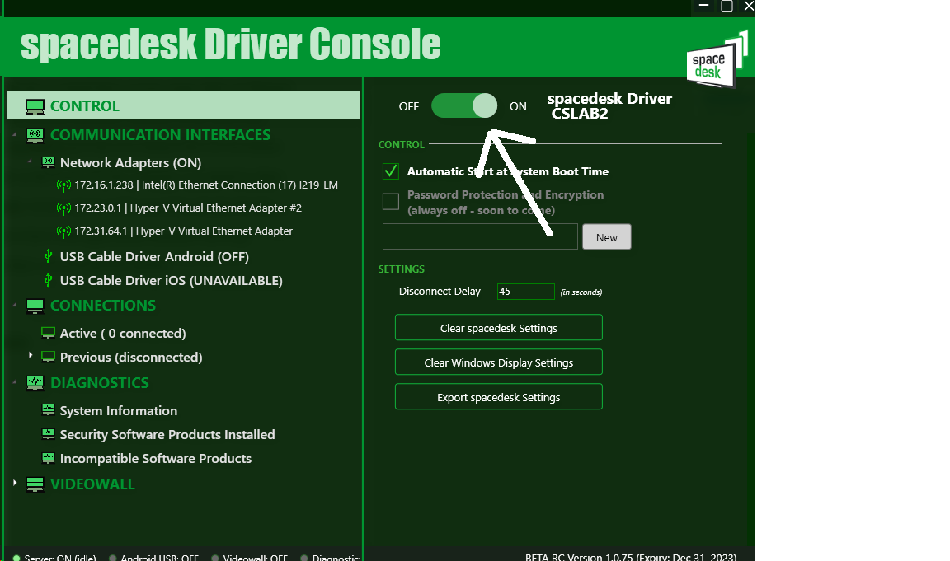

**2.) After activating the driver, proceed to another computer where the Spacedesk viewer is installed and launch the application. This will enable you to establish a connection with the primary server (machine), effectively serving as a second screen for the primary machine. To do this, you will need to know the IP address of the primary machine you wish to connect to.**

**-The picture below is an example of what it should look like when opening Spacedesk viewer. If you are not seeing any IP address then there might be a problem in the network, or the network was not configured properly.**

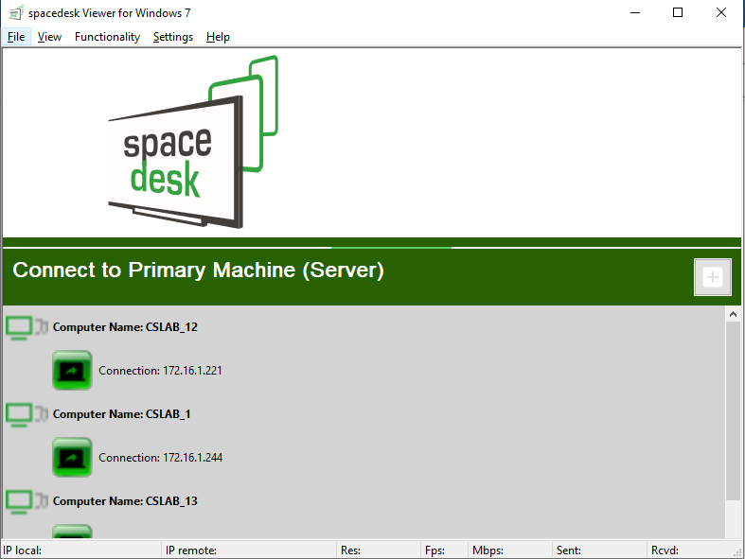

**3.) If you know the IP address of the primary machine, then click on the IP address and connect to it by clicking on the connection below the computer name.**

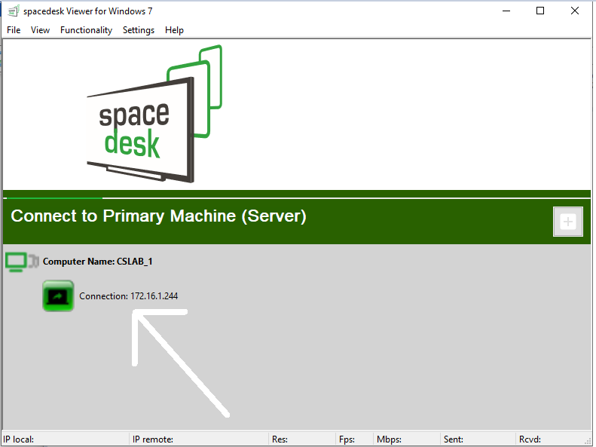

**4.) After clicking on the connection, it should connect to the primary machine and serve as another screen.**

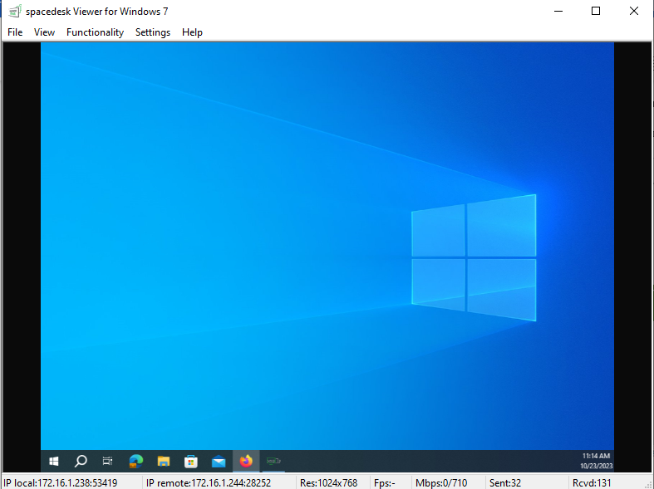

Windows 10 could not duplicate three or more screens they are limited by two screens. If you want to duplicate an application window across the screen, then **OntopReplica** is a good application to use for cloning an application window on multiple screens.

**Step by Step guide for using OntopReplica:**

**1.) After installing OntopReplica, open the application and the application should look like this.**

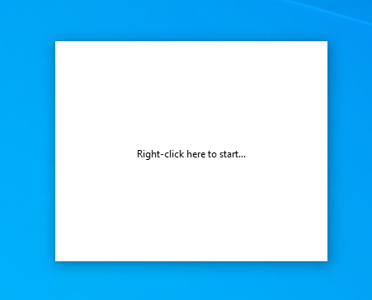

**2.) After right clicking the. Go to select window and choose an application that you want to stream.**

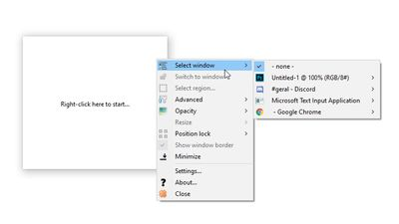

**3.) You can stream the same application on multiple windows by reopening the application and choosing the application again.**

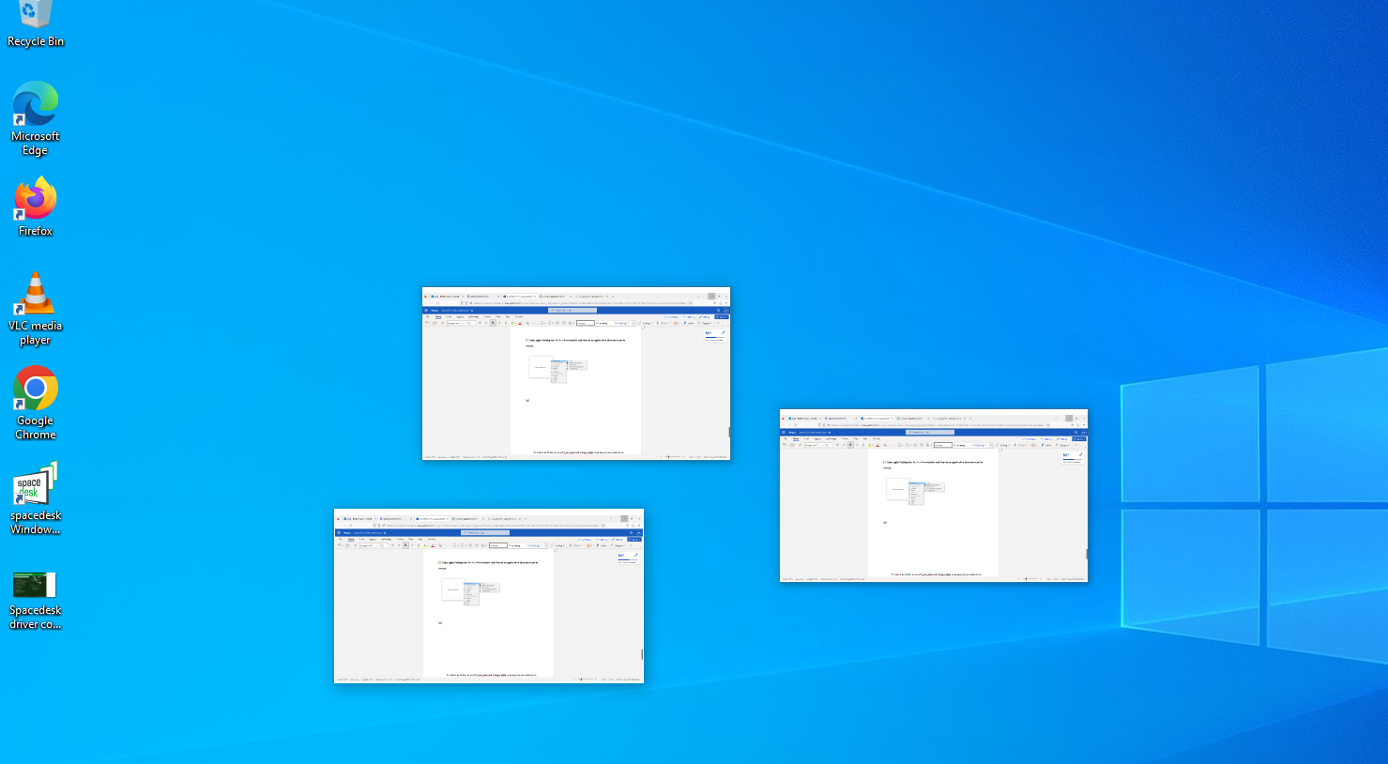

**-You can also enlarge the screen by double clicking the specific OntopReplica screen**

**Can you use Spacedesk and Ontopreplika on TV’S ?**

Tv’s have no ability to install Spacedesk and Ontopreplika so to screenshare on tv’s one must connect a computer to the tv using the HDMI output so a computer can extend their screen. By doing this the TV is now connected to the computer allowing the tv to show the Space desk window which in any users can connect if they are connected to the same network.

More information on the software that is used:

-Spacedesk (<https://manual.spacedesk.net/>)

-Ontopreplika (<https://github.com/LorenzCK/OnTopReplica/blob/master/README.md>